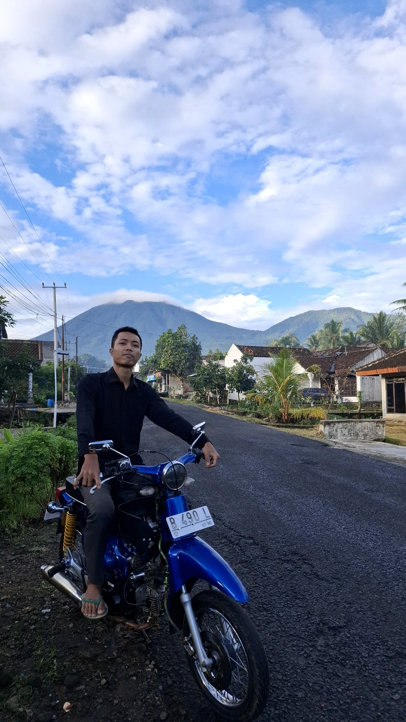 |  |  | ferdi kurniawan
kontak  0877777656565  someone@example.com  www.excellentwebsite.com  data diri  Create & Co,  321 Avenue A  Portland, OR 76543 |  |  | pendidikan  I’m writing to express my interest in any future graphic design positions at Create & Co. With a solid background in graphic design and a passion for creativity, I’ve had the pleasure of leading creative campaigns at AmCell Mobile and refreshing brand identities at Starling and Copper.  Create & Co.’s innovative and collaborative environment excites me, and I’d love to contribute my skills to your team. I look forward to the opportunity to connect.  Best regards,  Quarantino Esposito

